1. What are the advantages of collection Frameworks in java?

Ans: Collection is a Framework that is used for storing and manipulating a group of objects. Advantages are:

1. Reduced Programming effort by using core collection classes rather than implementing our own collection classes.
2. Reusability and interoperability.
3. Increase program speed and quality.
4. Reduces to learn and to use new API’s.
5. Reduces effort to design new API’s.

2.What do you understand by collection framework in java?

Ans: The collections framework gives the programmer access to prepackaged data structure as well as algorithms for manipulating them. It provides many interfaces, classes and methods.

3. Describe the collection hierarchy in java?

Ans: 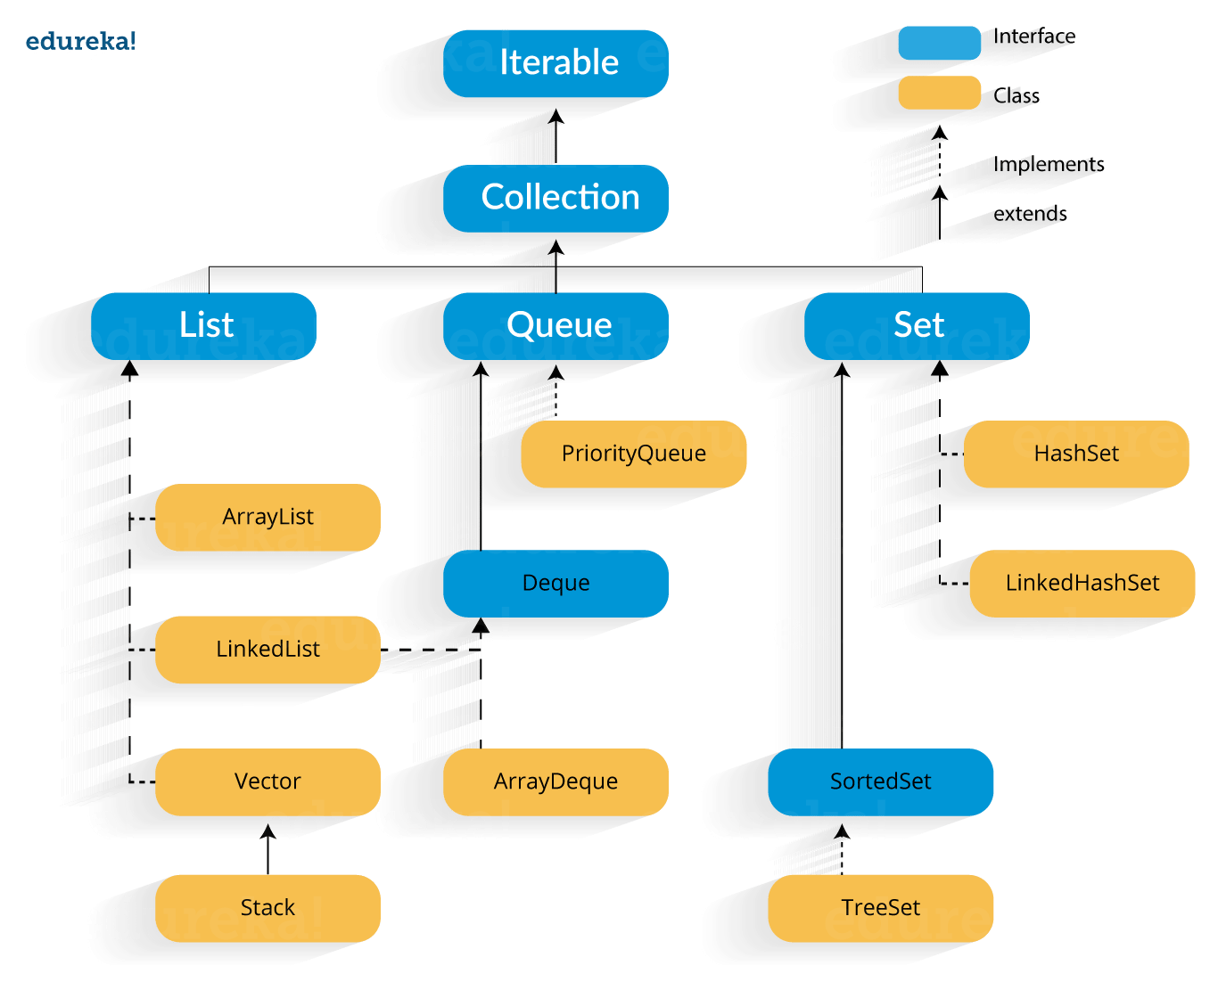

4.What do you understand by iterator in the java collection framework?

Ans: An iterator over a collection. Iterator takes the place of enumeration in the java collections framework. Iterator differ from enumeration in 2 ways:

a) Iterator allows the caller to remove the elements from underlying collection during the iteration with well-defined semantics.

b) Method names have been improved. Like: hasNext(), next(), remove().

5.How the collection objects are sorted in java?

Ans: In the collection, sort works is that it actually takes the collections underlying array, and calls its “sort()” method to sort the actual element.

To sort an object by its property, we have to make the object implement the

“ Comparable interface “ and override the “compareTo()” method.

6.What is the use of List interface?

Ans: List is a child interface of collection. It is an ordered collection of objects in which duplicates values can be stored. List preserves the insertion order, it allows positional access and insertion of elements.

List interface is implemented by the classes of ArrayList, Linked List, Vector and Stack.

7.What is Array List in Java?

Ans: ArrayList in java is used to store dynamically sized collection of elements. Contrary to Arrays that are fix in size , an ArrayList grows in size automatically when new elemnts are added to it .

An ArrayList is a re-sizable array, also called as “Dynamic Array”.

8.How do you convert an ArrayList to Array and Array to ArrayList?

Ans: Converting an ArrayList to Array will be done by using “toArray()”.

toArray() method returns an array containing all of the elemnts in the list in proper sequence . Syntax: 1. public Object[] toArray();

2.public<T> T[] toArray(T[] a);

Converting Array to ArrayList Syntax:

Method 1: Conversion using Array.asList()

ArrayList<Element>arrayList = new ArrayList<Element>(Arrys.asList(arrayname));

Method 2: Collections.addAll method

String array[]= {new item(1), new item(2), new item(3),new item(4)};

ArrayList<T>arraylist = new ArrayList<T>();

Collections.addAll(arraylist,array); (or)

Collections.addAll(arraylist, new item(1),new item(2), new item(3), new item(4);

9. How will you reverse a List?

Ans: A reverse() method is a java.util.collections class method. It reverses the order of elements in a list passed as an argument.

10.What do you understand by LinkedList in java? How many types of LinkedList does java support?

Ans: LinkedList is a sequence of links which contains items. each link contains a connection to another link.

Syntax: LinkedList object=new LinkedList();

LinkedList are of two types to store elements ,they are: 1) Singly LinkedList

2) Doubly LinkedList

11. What is a vector in java?

Ans: Vector class in java. The vector class implements growable array of objects. They are very similar to ArrayList but vector is synchronized . Like ArrayList it also maintains insertion order but it is rarely used in non-thread environment as it is synchronized and due to which it gives poor performance in searching , adding, delete and updates of its elements.

It extends AbstractList and implements List interfaces.

12.What are the various methods provided by the Queue interface?

Ans: Methods of Queue interface: \* Boolean add(E e) \* E element()

\* Boolean offer(object) \* E remove() \* E poll() \* E peek()

13.What is a Priority Queue in java?

Ans: Priority Queue serves the request as based on priority rather than FIFO.

Priority Queue implements Queue interface. The elements of the priority queue are ordered according to their natural ordering , or by a “comparator” at the queue construction time.

14. What is the Stack class in java and what are the various methods provided by it?

Ans: Stack is a subclass of “Vector “ that implements a standard last in , first -out stack. Stack only defines the default constructor , which creates an empty stack. Stack includes all the methods defined by Vector, and adds several of its own.

Object push(object element), Object pop(), object peek(), Boolean empty(),

Int search(object element).

15. What is set in java collections framework and list down its various implementations?

Ans: The Set interface. A Set is a collection that cannot contain duplicate elements. It models the mathematical set abstraction, two set instances are equal if try contain the same elements. There are 3 set implementations:

HashSet, TreeSet and LinkedHashSet.

16. What is the HashSet class in java and how does it store elements?

Ans: Java HashSet class is used to create a collection that uses a hash table for storage. It inherits the AbstractSet class and implements Set interface. The most important thing is HashSet stores the elements by using a mechanism called “hashing”.

17. Can you add null element in to a TreeSet or HashSet?

Ans: The HashSet object allows “null values” but , you can add only ”one null element”.

Whereas, in TreeSet if you tried to add null element it generates a “NullPointerException” at the run time.

18. What is LinkedHashSet in java collections framework?

Ans: The LinkedHashSet is an ordered version of HashSet which internally maintains one doubly linked list running through its elements. This doubly linked list is responsible for maintaining the insertion order of the elements.

19.What is a Map interface in java?

Ans: The java.util.Map interface represents a key and a value. A map cannot contain duplicate keys and each key can map to at most one value.

20. List down the different collection views provided by the Map interface in the collection framework?

Ans: Map interface provides 3 collection views : Set<K>keyset(), this returns a set view of the keys contained in the map. The collection supports element removal , which removes the corresponding mapping from the map, via the iterator remove , collection . remove, removeAll, retianAll and clear operations.

21. Difference between Comparable and Comparator?

Comparable Comparator

\*Comparable provides single sorting sequence \*Comparator provides multiple

Sorting sequence.

\*Comparable affects the original class \*Comparator doesn’t affect the

Original class

\*Comparable provides compareTo() \* Comparator provides

Method to sort elements compare() method to sort element

\*Comparable is present in java.lang \*Comparator present in java .util package package.

\*Sorting can be done by using \*Sorting can be done by

collections.sort(list) Collections.sort(List,comparator) .